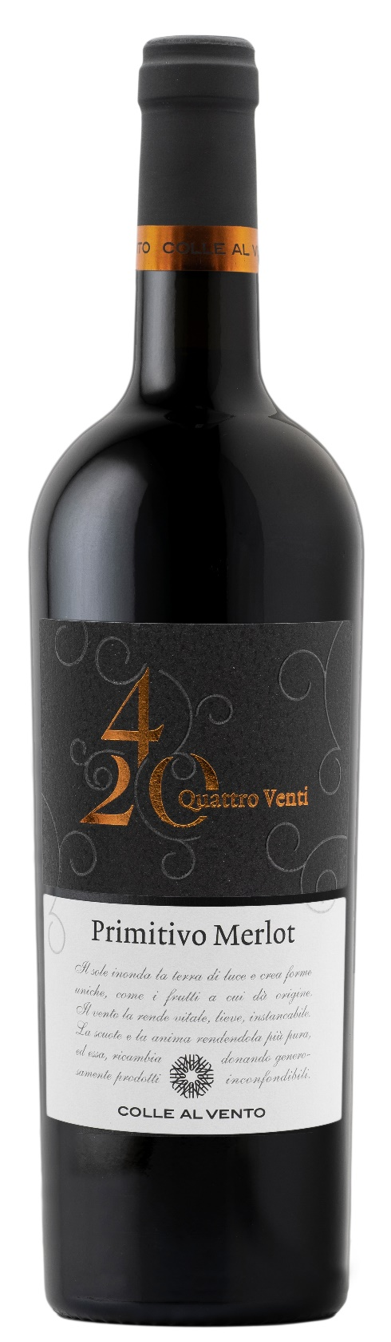
PRIMITIVO MERLOT PUGLIA IGP – 4/20

Grape: Primitivo 50%, Merlot 50%
Alc. Vol.%: 13,5
Vintage: 2025
Residual sugar g/l: 8,0
Total acidity g/l: 5,5
Region: Apulia
Production zone: Vineyards in Central Apulia (Bari)
Capacity: 750ml

CHARACTERISTICS

Vinification: After a soft pressure and the separation of grape-stalk, traditional maceration and short fermentation at a controlled temperature
Aging: Aged in steel tanks for at least 6 months
Yield per ha: 12000kg
Colour: Intense red with purple reflections
Bouquet: Aromas of flowers and herbs together with notes of mature fruits
Flavour: Elegant, full-bodied and harmonious

SERVING SUGGESTIONS

Excellent with spicy starters, pasta, poultry and cheese.
Serving temperature 16-18 °C
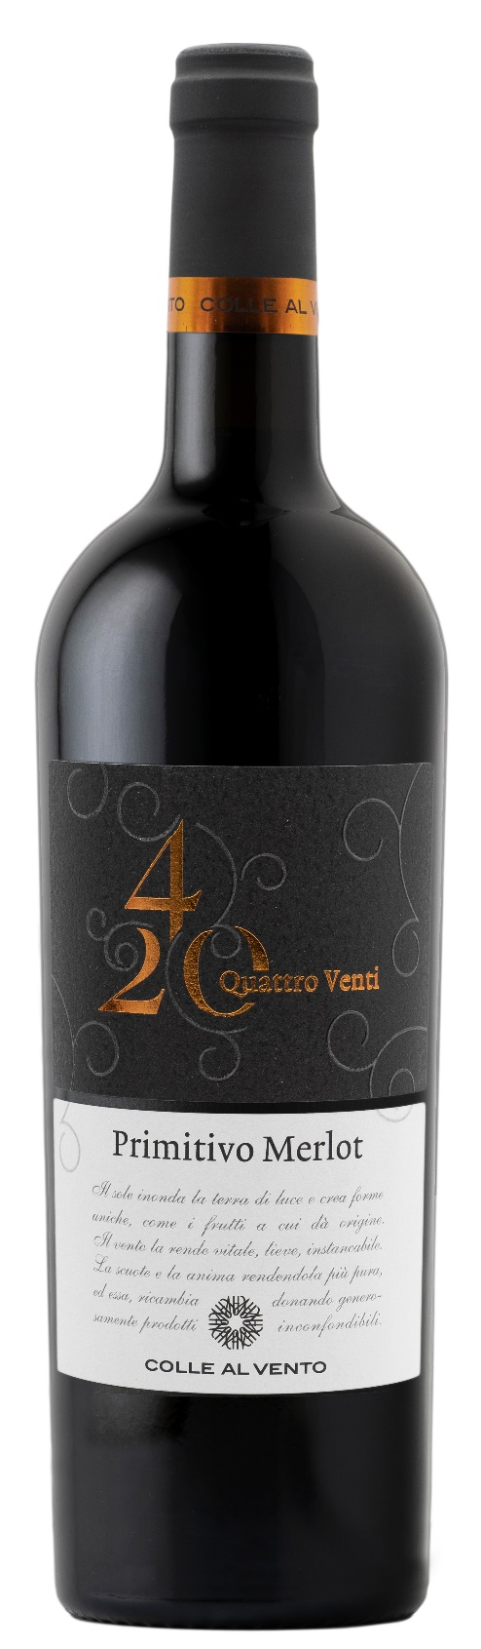
TECHNICAL INFORMATION / PALLETIZING

Size 750ml:
Article Nr. V03012A
GTIN-13 bottle 8017868001744
GTIN-13 carton 8017868002000
Closure Cork
Bottles / carton 6 bottles
Pallet size 80x120cm
Cartons/layer 21
Cartons/pallet 105
Kg/carton 7,8
Kg/pallet 840

Contains sulphites
GMO Free
Revisione 01. 14.05.2026

